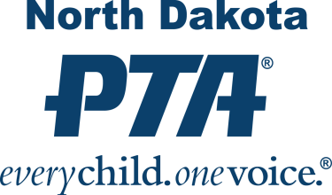

**PTA Mission, Vision and Values**

Membership is open to anyone who believes in the mission and purposes of Parent Teacher Association. Individual members may belong to any number of PTAs and pay dues in each. Every person who joins a local PTA® automatically becomes a member of both the state and national PTAs.

Together we are a powerful voice for children. With your help, we can continue to work toward PTA's goal of a quality education and nurturing environment for every child.

**PTA Mission:**

*“To make every child’s potential a reality by engaging and empowering families and communities to advocate for all children.”*

**PTA Values:**

What PTA stands for:

***Collaboration:*** *We will work in partnership with a wide array of individuals and organizations to broaden and enhance our ability to serve and advocate for all children and families.*

***Commitment:*** *We are dedicated to children’s educational success, health, and well-being through strong family and community engagement, while remaining accountable to the principles upon which our association was founded.*

***Diversity:*** *We acknowledge the potential of everyone without regard, including but not limited to: age, culture, economic status, educational background, ethnicity, gender, geographic location, legal status, marital status, mental ability, national origin, organizational position, parental status, physical ability, political philosophy, race, religion, sexual orientation, and work experience.*

***Respect:*** *We value the individual contributions of members, employees, volunteers, and partners as we work collaboratively to achieve our association’s goals.*

***Accountability:*** *All members, employees, volunteers, and partners have a shared responsibility to align their efforts toward the achievement of our association’s strategic initiatives.*