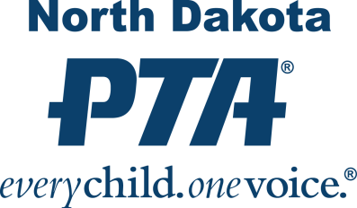
North Dakota PTA
“Friend of Child” Award

History, Criteria & Nomination Form

Established in August 1992, The “Friend of Child” Award was created as a way to honor those who have given exemplary service to children and youth. This award can be given once a year in those years when an appropriate recipient is identified.

This award was established as a way to honor a worthy person in the school, community, or state that exhibits the following criteria:
• Gives outstanding service to children.
• Demonstrates continued interest in the well-being of children and youth.
• Serves as an advocate for children in the areas of education, health, safety or legislation.
• Is an individual who cares about children and has made his or her caring count by their devoted service to youth.
Past Friend of Child Award Recipients
2020 Cheryl Simmons
2021 Dani Parkos Fluge

2007 Tracey Lawson
2008 Linda Schroeder
2009 Jr. Achievement—Minot
2010 Nancy Jordheim
2011 Trollwood Performing Arts School
Founders, Vicki Chepulis & John Marks
2012 Helane Robson
2013 Penny & Pals - Penny Andrist &
Gail Benson
2014 Jeannie Baskerville
2015 Senator John Hoeven
2016 Marcia Hellevang
2017 Mary Schultz
2018 Rory Biel
2019 Laura Sokolofsky
1993 Dr. Lowell Latimer
1994 Dr. Wayne Sanstead
1995 Dr. Vern Bennett
1996 Linda McGuire
1997 Rachael Disrud
1998 Glenn Melvey
1999 ND Elementary and Secondary
Principals Association
2000 Phyllis Seir
2001 Laura Carney
2003 Mike Fogarty
2004 Lowell Wolff
2005 Curt Medalen
2006 Mavis Bennett

To make a nomination, please complete the following form. Nominations accepted from current NDPTA Board members and or Convention planning committee members.

North Dakota PTA

“Friend of Child” Award
2022 Nomination Form
DEADLINE: September 15th, 2022
Please complete the nomination form and return via email to ndpta@gmail.com

Nominee
Full Name: _________________________________________________________________________
Address: ___________________________________________________________________________
Phone: _______________________________ Email: _______________________________________
Family Member: ______________________________________ Phone: ________________________

Nominator
Full Name: _________________________________________________________________________
Phone: _______________________________ Email: _______________________________________

Reason for Nomination

____________________________________________________________________________________________________________________________________________________________________________________________________________________________________________________________________________________________________________________________________________________________________________________________________________________________________________________________________________________________________________________________________________________________________________________________________________________________________________________________________________________________________________________________________________________________________________________________________________________________________________________

