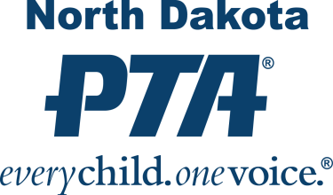

PTA Mission, Vision and Values
Membership is open to anyone who believes in the mission and purposes of Parent Teacher Association. Individual members may belong to any number of PTAs and pay dues in each. Every person who joins a local PTA® automatically becomes a member of both the state and national PTAs.
Together we are a powerful voice for children. With your help, we can continue to work toward PTA's goal of a quality education and nurturing environment for every child.
PTA Mission:
The overall purpose of PTA:
“To make every child’s potential a reality by engaging and empowering families and communities to advocate for all children.”
PTA Vision:
What the future will look like if PTA accomplishes its mission of making every child's potential a reality.
PTA Values:
What PTA stands for:
Collaboration: We work in partnership with a wide array of individuals and organizations to accomplish our agreed-upon goals.
Commitment: We are dedicated to promoting children’s health, well-being, and educational success through strong parent, family, and community involvement.
Accountability: We acknowledge our obligations. We deliver on our promises.
Respect: We value our colleagues and ourselves. We expect the same high quality of effort and thought from ourselves as we do from others.
Inclusivity: We invite the stranger and welcome the newcomer. We value and seek input from as wide a spectrum of viewpoints and experiences as possible.
Integrity: We act consistently with our beliefs. When we err, we acknowledge the mistake and seek to make amends.

