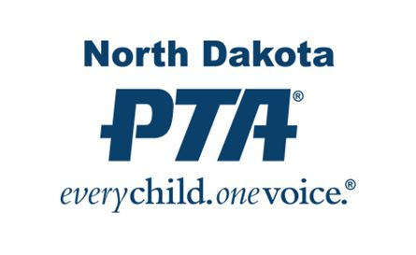

NORTH DAKOTA PTA
LIFETIME ACHIEVEMENT AWARD

How do you say: Thank you for your outstanding service to our children....give the award of a lifetime!

Recognize and thank that special person you know who goes above and beyond for all children—the one who acts as a tireless advocate for children’s education, health, and well-being.
The recipient of the North Dakota PTA Lifetime Achievement Award will receive a certificate of recognition, from the North Dakota PTA President and an honorary lapel pin from the North Dakota PTA.
The $40 fee for presenting the Lifetime Achievement Award supports NDPTA. Your honoree need not be a PTA member to receive the award. Presenting the North Dakota PTA Lifetime Achievement Award at a ceremony recognizing your honoree’s work will generate positive publicity and bring together your school, your community, and PTA.
To honor that special person who lives out his or her commitment to children, give the North Dakota PTA Lifetime Achievement Award now. Just complete the attached form and submit to the NDPTA Office at the address listed.

North Dakota PTA Lifetime Achievement Award

(Please print and use one order form per honoree)

UNIT REQUESTING AWARD:

Name of PTA: ___________________________________________City:___________________
HONOREE:

Surname: Mr Mrs Miss Ms Dr

First Name _________________________________ Last________________________________

Address: _______________________________________________________________________

City: _______________________________________________Zip:________________________

Email: _________________________________________________________________________

PRESENTATION DETAILS:

Date of Presentation: _______________ (Will be mailed to person below in time for presentation)

Name_________________________________________________________________________

Address: _______________________________________________________________________

City: ___________________________________________________Zip:____________________

Email: _________________________________________________________________________

Daytime Phone: (_______) ________________________________________________________

Please allow 2 weeks for processing

North Dakota PTA Lifetime Achievement Award $40 (Includes standard shipping)

Special Shipping and Handling Fee $10 (Required for rush orders or special handling)

Total Amount (enclose this amount) $___________________________________________

Mail order form and a check to:
North Dakota PTA
PO Box 943
Fargo, ND 58107

