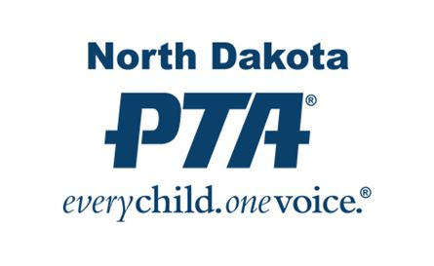
Welcome to the 2022-23 PTA Year!
On behalf of North Dakota PTA, we welcome you to another exciting school year. The NDPTA State Office is always available as a resource for you at the contact information listed below. Make sure you visit our website at ndpta.org and our Facebook Page, North Dakota PTA, to keep up to date on all that is currently happening in PTA!
Running a PTA is an exciting and challenging endeavor and we are glad to have you on board! Included in this letter is all of the important information you need to get your year off to a great start and operating under NDPTA guidelines.

- NDPTA Unit in Good Standing/Standards of Affiliation – Consider this your checklist of required items along with all the important due dates that you need to know. As an affiliate of NDPTA and National PTA, these are the requirements for your unit to remain in compliance with the standards set forth to function as a PTA and to retain your tax exempt status with the IRS.

- Unit Insurance – NDPTA requires each of its units to hold at a minimum General Liability Insurance. It is one of the required items listed in the Standards of Affiliation above. Insurance is provided through AIM Insurance and you will receive a separate letter from AIM outlining their available insurance coverage choices at the beginning of August. Insurance is due to AIM no later than October 15th of each year.

- NDPTA Lifetime Achievement Award - The NDPTA Lifetime Achievement Award is the perfect way to say “Thank You” to that special person for their contributions to PTA and our youth. It can be given at any time during the year.

- PTA Mission, Vision and Values - Do you ever get asked what exactly the PTA stands for? This document states all of the guiding principles in a very simple format. It is a great one to pass out at every PTA meeting to make sure that your members are aware of what those guiding principles are.

As always, please feel free to contact the NDPTA State Office for any questions or concerns you may come across. Our Office Director is willingly available to provide communication and resources to all of our local units and to help maintain communication between National PTA, State PTA and Local PTA Units. Please do not hesitate to ask for help or guidance in any situation. Please keep this letter and all of the forms for reference throughout the year.
It is going to be an exciting year for NDPTA! Remember to reach out to those new faces you see at the beginning of the year and invite them to become part of your PTA family. Especially seek out those families with younger children or those that are new to your school so they can join today and be a part of your future. We look forward to working with each of you throughout the year ahead.
Thank you for being an important part of our PTA!
North Dakota PTA
PO Box 943
Fargo, ND 58107
701.371.4550
northdakotapta@gmail.com
Dani Parkos Fluge, State Office Director

